From last

1. number=53

i=2

flag=0

while test $i -le `expr $number / 2`

do

if test `expr $number % $i` -eq 0

then

flag=1

fi

i=`expr $i + 1`

done

if test $flag -eq 1

then

echo "The number is Not Prime"

else

echo "The number is Prime"

Fi

1. 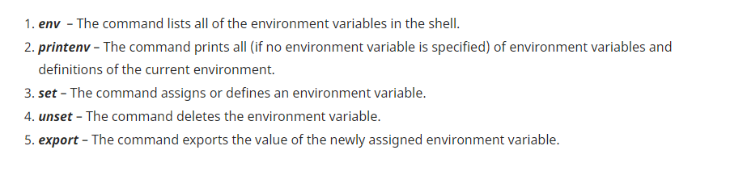
2. 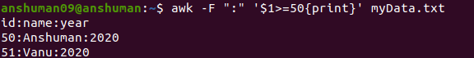
3. 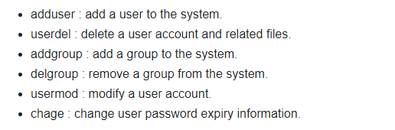
4. 
5. 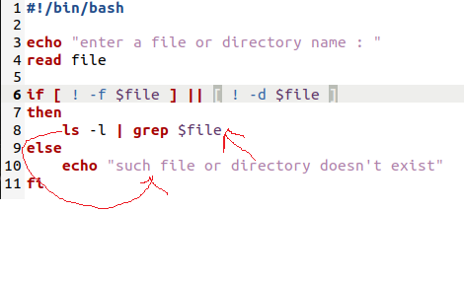
6. 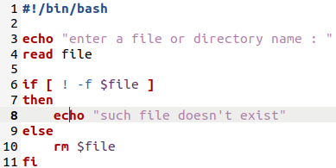
7. 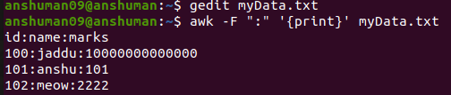
8. 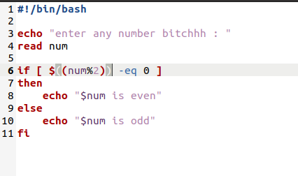
9. 